Eiffel Tower

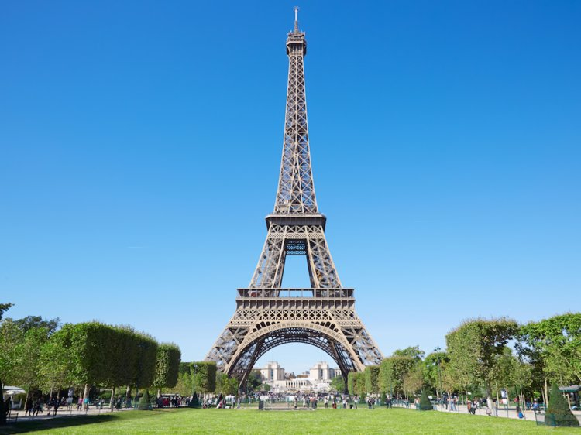

The Eiffel Tower is a wrought iron lattice tower on the Champ de Mars in Paris, France. It is named after the engineer Gustave Eiffel, whose company designed and built the tower. The Eiffel Tower was constructed in 1887–89 as the entrance to the 1889 World's Fair. The tower is 324 metres (1,063 ft) tall, about the same height as an 81-storey building, and the tallest structure in Paris. Since it opened in 1889, almost 250 million visitors have come to see the tower. The Eiffel Tower has 20,000 light bulbs, 5,000 per side, that sparkle for five minutes on the hour, every hour, from nightfall to 1AM.

Hanging Gardens of Babylons

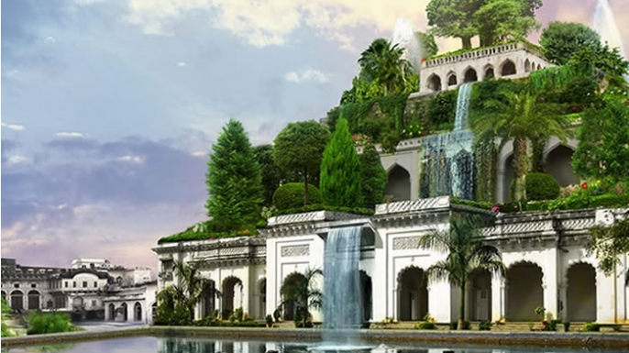

Hanging Gardens of Babylon, gardens considered one of the Seven Wonders of the World and thought to be located near the royal palace in Babylon. a number of descriptions concurred that the gardens were located near the royal palace and were set upon vaulted terraces. They were also described as having been watered by an exceptional system of irrigation and roofed with stone balconies. Some research suggested that the gardens were laid out on a sloping construct designed to imitate a natural mountain landscape and were watered by a novel system of irrigation, perhaps making early use of what would eventually be known as the Archimedes screw. Accounts indicate that the garden was built by King Nebuchadnezzar, who ruled the city for 43 years starting in 605 BC. the gardens were built to cheer up Nebuchadnezzar's homesick wife, Amyitis.

Great Wall of China

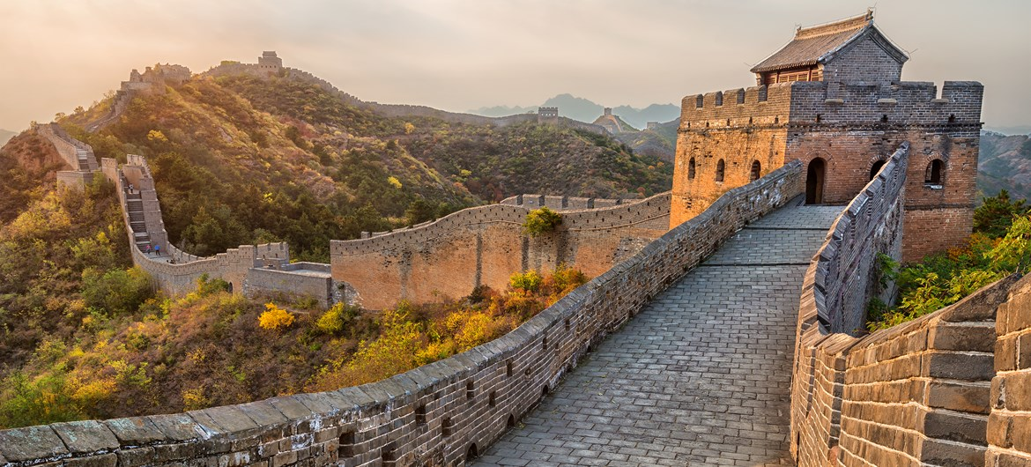

The Great Wall of China is one of the greatest wonders of the world. Just like a gigantic dragon, it winds up and down across deserts, grasslands, mountains and plateaus, stretching approximately 21,196 kilometers from east to west of China. The Great Wall was originally built in the Spring and Autumn, and Warring States Periods as a defensive fortification by the three states: Yan, Zhao and Qin. It went through constant extensions and repairs in later dynasties. It began as independent walls for different states when it was first built, and did not become the "Great" wall until the Qin Dynasty. An amazing thing about the Great Wall is that it is also visible from space.the long-extending Great Wall worked as a complete and solid military defense line. Other purposes of the Great Wall have included border controls, allowing the imposition of duties on goods transported along the Silk Road, regulation or encouragement of trade and the control of immigration and emigration.

Aztec Pyramid

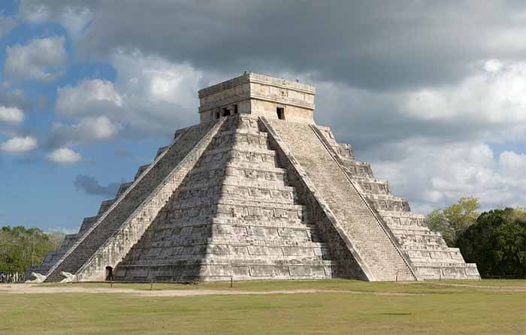

Aztec temples were usually found at the top of pyramids and they are often called temple-pyramids. Designed using ancient Mesoamerican architectural traditions that went back thousands of years, temple-pyramids were tall structures forming four main platforms, with grand stairways running up one side. Temple-pyramids were used for religious ceremonies and sacrifice.The Aztecs believed their pyramids were the homes of their gods and places of worship. Burials have been found within their walls, and the pyramids were also used to perform rituals of sacrifice. Being ziggurats (pyramids with flat tops), pyramids from the Americas (including those of the Aztecs) were located inside busy cities, and were centres of regular worship and festivities, as well as centres of astrology and astronomy. This was unlike the Egyptian pyramids, which were built exclusively as the tombs of kings, and resting places of the dead.

Taj Mahal

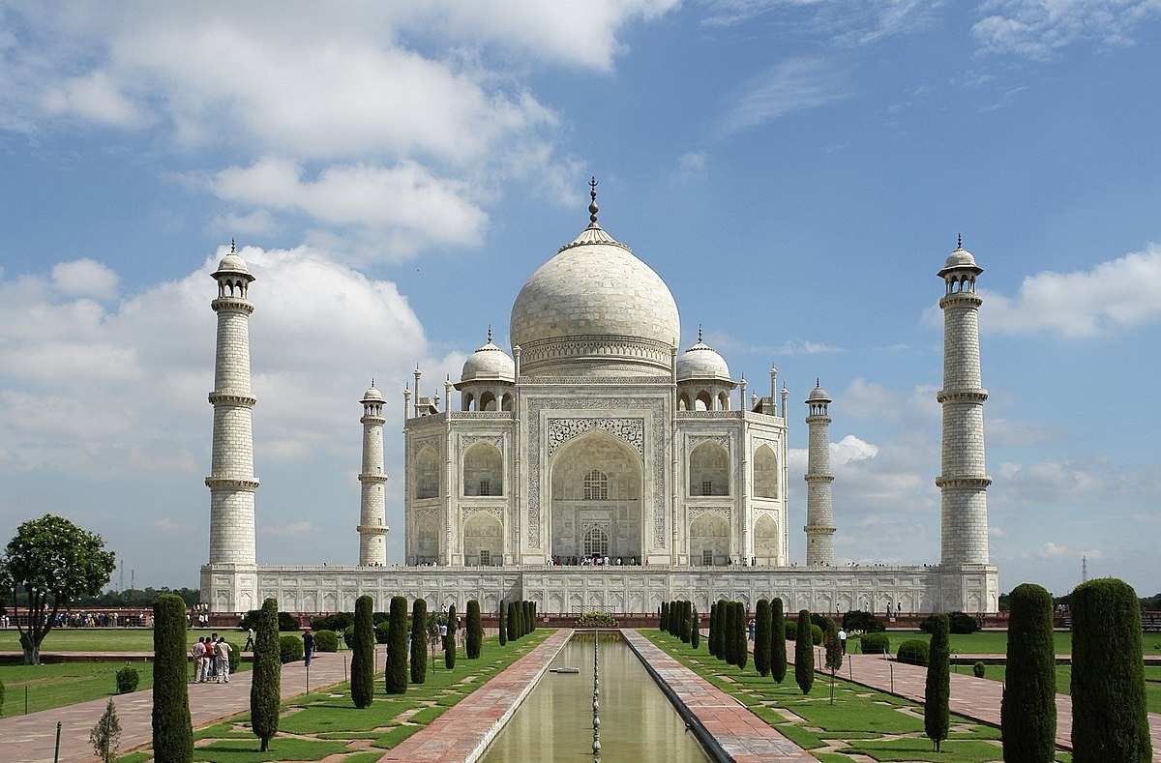

One of the eight wonders of the world, Taj Mahal is an excellent example of magnificent architectural beauty. Taj Mahal came into existence by the then Emperor, Shah Jahan. The idea, which prompted the Emperor to come with such a beautiful Monument, was in wake of his wife’s demise. Since his wife was dear to him, he dedicated the monument in the name of her. The unbridled beauty of Taj is immaculate and sways millions of tourists every year. Magnificently built with white marble, it becomes difficult to express its stunning architectural beauty in words. Without a tad of doubt, Taj looks surprisingly beautiful particularly at dawn and sunset. Taj Mahal was completed in its construction in a period of 22 years. The number of workers who were involved in the construction was nearly 20 thousand.

Pyramid

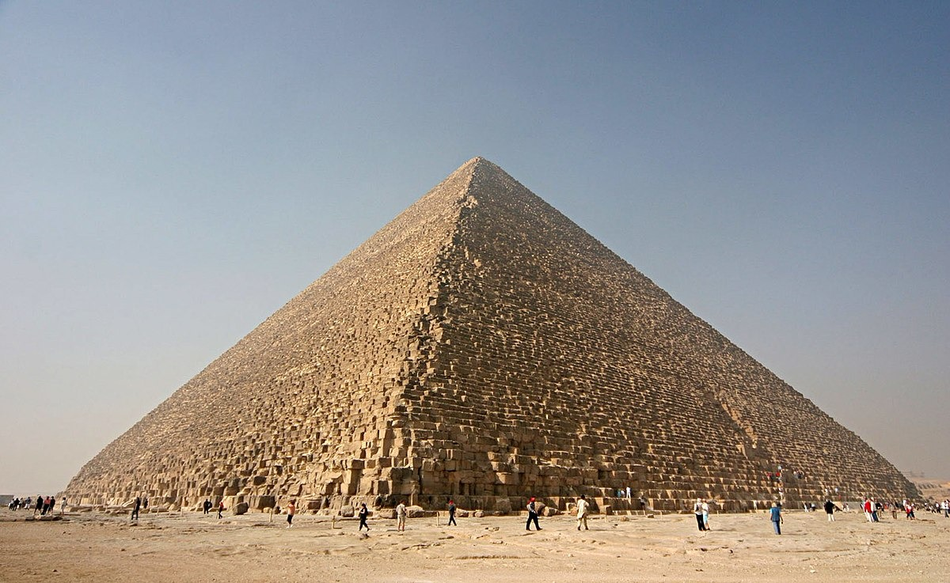

A pyramid is a structure whose outer surfaces are triangular and converge to a single point at the top, making the shape roughly a pyramid in the geometric sense. The base of a pyramid can be trilateral, quadrilateral, or any polygon shape. As such, a pyramid has at least three outer triangular surfaces. The square pyramid, with square base and four triangular outer surfaces, is a common version. A pyramid's design, with the majority of the weight closer to the ground, and with the pyramidion on top means that less material higher up on the pyramid will be pushing down from above. This distribution of weight allowed early civilizations to create stable monumental structures. Pyramids have been built by civilizations in many parts of the world. The largest pyramid by volume is the Great Pyramid of Cholula, in the Mexican state of Puebla. For thousands of years, the largest structures on Earth were pyramids

Leaning Tower of Pisa

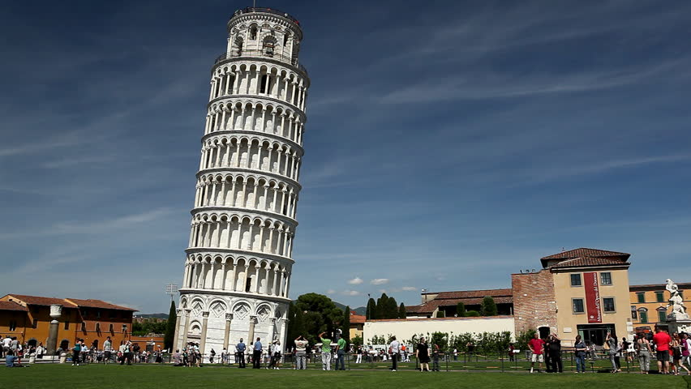

The Leaning Tower of Pisa or simply the Tower of Pisa is the campanile, or freestanding bell tower, of the cathedral of the Italian city of Pisa, known worldwide for its unintended tilt. The tower is situated behind the Pisa Cathedral and is the third oldest structure in the city's Cathedral Square,after the cathedral and the Pisa Baptistry. The tower's tilt began during construction in the 12th century, caused by an inadequate foundation on ground too soft on one side to properly support the structure's weight. The tilt increased in the decades before the structure was completed in the 14th century. It gradually increased until the structure was stabilized by efforts in the late 20th and early 21st centuries.

Christ the Redeemer (statue)

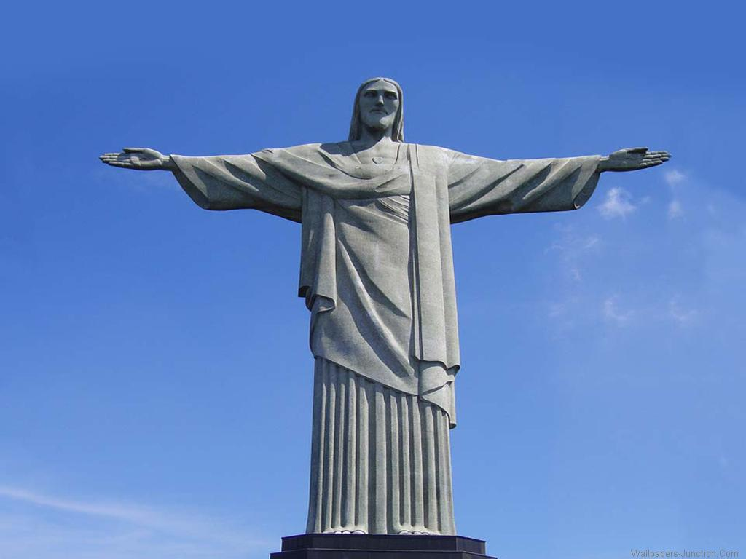

Christ the Redeemer is an Art Deco statue of Jesus Christ in Rio de Janeiro, Brazil, created by French sculptor Paul Landowski and built by the Brazilian engineer Heitor da Silva Costa, in collaboration with the French engineer Albert Caquot. Romanian sculptor Gheorghe Leonida fashioned the face. Constructed between 1922 and 1931, the statue is 30 metres tall, excluding its 8 metre pedestal, and is located at the peak of the 700 metre Corcovado mountain in the Tijuca Forest National Park overlooking the city of Rio de Janeiro. A symbol of Christianity across the world, the statue has also become a cultural icon of both Rio de Janeiro and Brazil, and is listed as one of the New Seven Wonders of the World. It is made of reinforced concrete and soapstone.

Big Ben

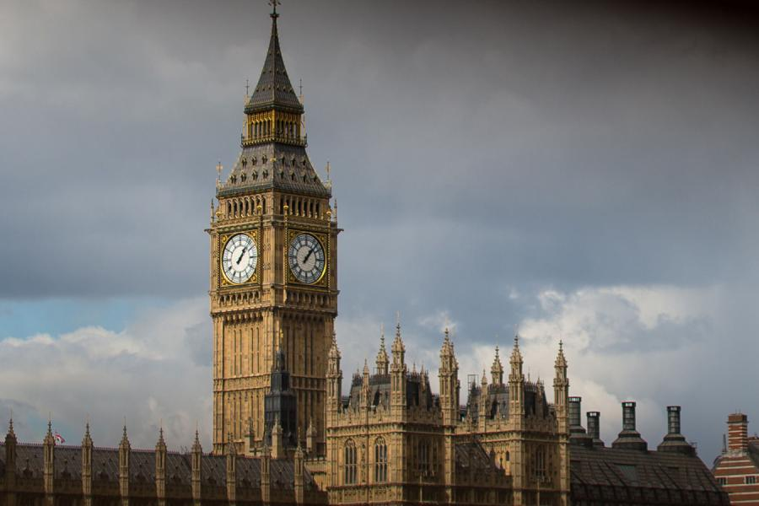

Big Ben is the nickname for the Great Bell of the clock at the north end of the Palace of Westminster in London and is usually extended to refer to both the clock and the clock tower. The tower is officially Elizabeth Tower, renamed to celebrate the Diamond Jubilee of Elizabeth II in 2012; until then, it was known simply as the Clock Tower. The tower was designed by Augustus Pugin in a neo-gothic style. When completed in 1859, it was, says horologist Ian Westworth, "the prince of timekeepers: the biggest, most accurate four-faced striking and chiming clock in the world". It stands 315 feet tall, and the climb from ground level to the belfry is 334 steps. Big Ben is the largest of five bells and weighs. It was the largest bell in the United Kingdom for 23 years.

Colosseum

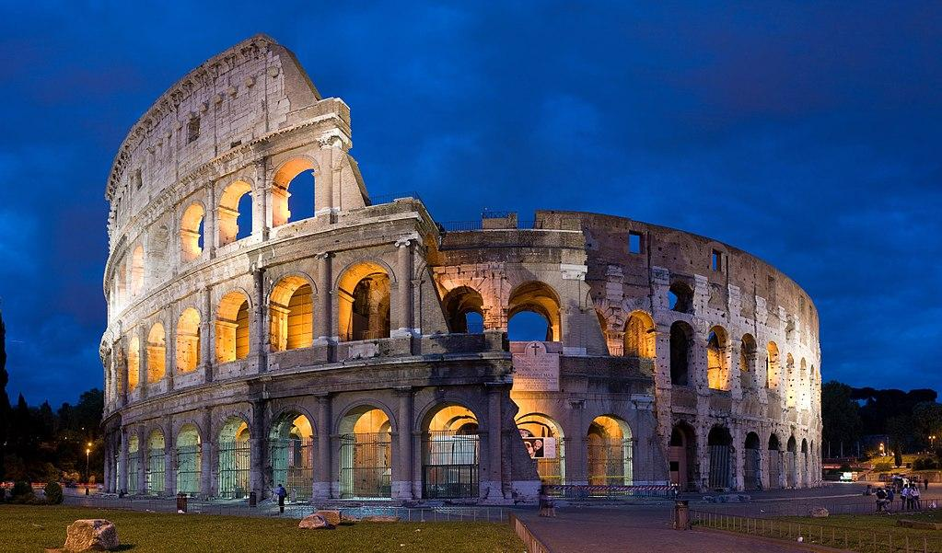

The Colosseum or Coliseum, also known as the Flavian Amphitheatre or Colosseo, is an oval amphitheatre in the centre of the city of Rome, Italy. Built of travertine, tuff, and brick-faced concrete, it is the largest amphitheatre ever built. The Colosseum is situated just east of the Roman Forum. Construction began under the emperor Vespasian in AD 72, and was completed in AD 80 under his successor and heir Titus. Further modifications were made during the reign of Domitian (81–96). These three emperors are known as the Flavian dynasty, and the amphitheatre was named in Latin for its association with their family name (Flavius). The Colosseum could average audience of some 65,000. The building ceased to be used for entertainment in the early medieval era. It was later reused for such purposes as housing, workshops, quarters for a religious order, a fortress, a quarry, and a Christian shrine.